Room D
DQ1 Incarcerated Inguinal Hernia
Stem:: You are consulted on a A 59-year-old male. He presents with 3 days of abdominal pain, numerous episodes of bilious emesis and a visible, tender right groin mass.
PMH/PSH: with CAD s/p stent x3 in 2015, HTN, HLD, morbid obesity (BMI 43) and a history of a previously reducible right inguinal hernia.
PE : He is tachycardic to 105, otherwise vitals are stable. His abdomen distended, and TTP along the RLQ but non-peritoneal.
Labs: WBC: 11.5k. Otherwise normal.

- What is your differential diagnosis?
  - Incarcerated inguinal hernia.
  - Strangulated inguinal hernia.
  - Femoral hernia
  - Adhesive SBO
  - Infected lymph node
  - Orchitis, Testicular torsion
What test / studies you want?
- CT scan:
- 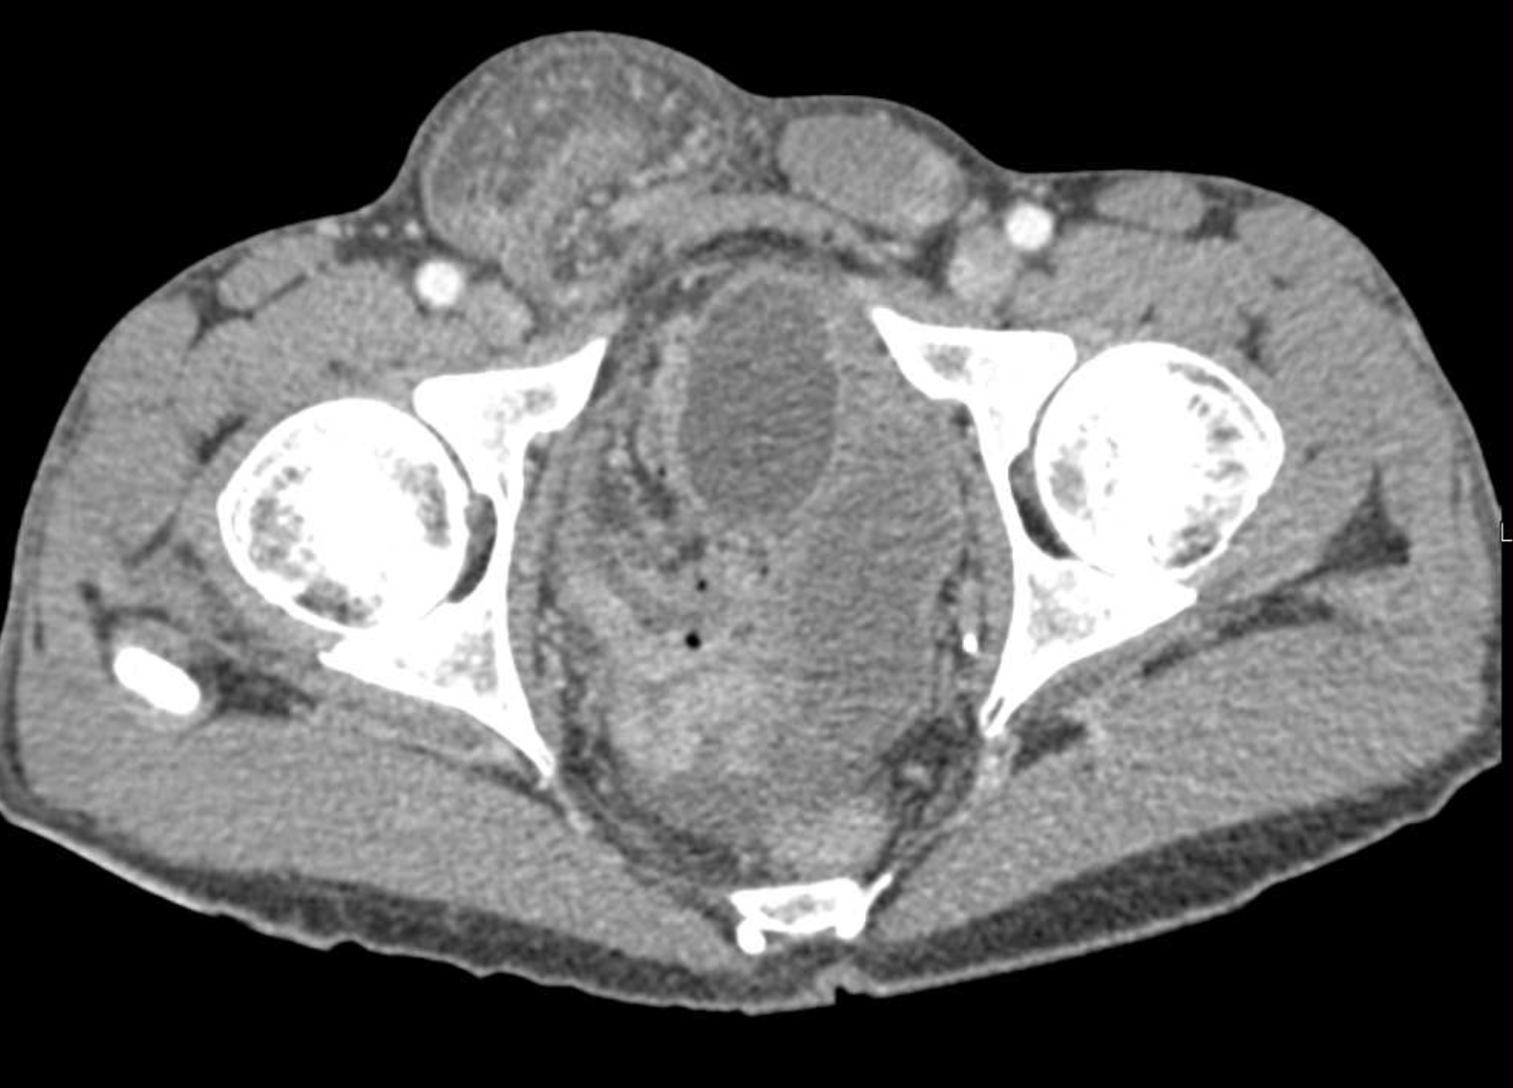
- Right inguinal hernia with bowel loops that appear enhancing and a small amount of free fluid within the hernia sac.
Now what?
- Proceed to the operating room.
What would you consent the patient for and what risks would you describe?
What Approach? (Consent should include chronic pain)
- Inguinal incision.
- Assess bowel.
  - Bowel viable but with inflammation → Reduce, repair, place mesh.
  - Bowel non-perforated but ischemic requiring resection → tissue repair vs. mesh repair are both acceptable
  - Bowel necrotic and perforated → no mesh. Should do tissue repair.
Describe your approach in inguinal hernia repair?
- Lichtenstein:
  - Incision 1 cm above and parallel to the inguinal ligament, beginning from the pubic tubercle and extending 5-6 cm laterally.
  - The Scarpa fascia is similarly opened along the length of the incision, down to the external oblique aponeurosis.
  - The external oblique aponeurosis is then opened along the line of incision, starting from the external ring and extending laterally for up to 5 cm.
  - The superior and inferior flaps of the external oblique aponeurosis are gently freed from the underlying contents of the inguinal canal and overturned and separated to expose the cremaster with the cord structures.
  - identify and isolate the hernia sac.
  - Reduce content.
  - polypropylene mesh is commonly used
  - The first medialmost stitch fixes the mesh 2 cm medial to the pubic tubercle.
  - The same suture is then used as a continuous suture to fix the lower edge of the mesh to the free lower border of inguinal ligament up to a point just lateral to the internal ring.
  - a slit is made in the lateral end of the mesh
  - upper edge is then fixed to the rectus sheath and the internal oblique aponeurosis.
  - The two tails are then tucked together and fixed to the inguinal ligament just lateral to the internal ring, thus creating a new internal ring.
  - Close in layers.
- Can use plug and patch repair.
- Prolene hernia system.

McVay repair
  - The conjoined (transversus abdominis and internal oblique) tendon is sutured to the Cooper ligament with interrupted nonabsorbable sutures.

Bassini repair
  - Suturing the transversalis fascia and the conjoined tendon to the inguinal ligament behind the spermatic cord with monofilament nonabsorbable suture.

Shouldice repair

The transversalis fascia is incised from the internal ring laterally to the pubic tubercle medially, and upper and lower flaps are created. These flaps are then overlapped (double-breasted) with two layers of sutures.

The conjoined tendon is then sutured to the inguinal ligament, again in two overlapping layers.

Scenario 2: Different patient: 85 year old female who has a palpable, tender mass in the groin. Imaging has not been obtained. What are you concerned about? How would you approach this patient?

- 1. Femoral hernia.
- Can you describe McVay/Cooper’s ligament repair?
  - The conjoined (transversus abdominis and internal oblique) tendon is sutured to the Cooper ligament with interrupted nonabsorbable sutures.
Scenario 3: Different Patient: 85 year old female with weight loss over the last 6 months and now with abdominal pain, distention, bilious emesis. CT demonstrates an Obturator Hernia.
- What is the characteristic physical exam sign?
  - Howship-Romburg sign: pain in anteromedial aspect of thigh relieved with thigh flexion
  - What is your operative Approach?
    - laparoscopic vs. open repair
    - Mesh required for repair.
Pitfalls:
- Not taking the patient to the OR.
- Not knowing how to describe repair.
- Not knowing how to repair femoral hernia.
- Not knowing when to use mesh.

Reference: https://emedicine.medscape.com/article/1534281-technique?form=fpf#c3

DQ2 BURN
Stem: A 47 y/o male is brought to the ED by EMS after being evacuated from a bedroom fire, started while he was smoking in his bed.
Upon evaluation he is awake and conversive but appears confused.
He is noted to have 60% TBSA burns to his upper torso, sparing only his lower extremities. His nasal hair is singed and he has a productive cough with a hoarse voice.
HR- 115, RR- 30, BP – 95/50, Temp – 37C, SpO2-100%.

Additional Workup or Studies:
CMP, CBC, carboxyhemoglobin, lactate

What are you concerned about?!:
- Airway compromise with an upper airway inhalation injury
- Development of decreased pulmonary compliance with circumferential burns to the torso
- Carbon monoxide poisoning
- Hypothermia
- ARDS/multisystem organ failure
- Compartment syndrome in extremities or abdomen

What would you like to do now?
- Intubate – 100% FiO2
- Serial carboxyhemoglobin levels
- Establish adequate IV access and initiate fluid resuscitation using parkland formula:
2-4 ml/kg/%TBSA burn using LR. First ½ within 8 hours of burn.
Second ½ in the next 16 hours
- Place a foley to monitor resuscitation. Goal 30 – 50 cc/hr

Scenario : Patient is 100 kg, received 60% TBSA burn. He arrives four hours after his burn and has received a total of four liters of crystalloid. How would you manage his fluids at this point

Parkland: 100 kg * 60% *2ml/kg = 12L in first 24 hours, 6L in first 8 hours. Patient has already received 4L 🡪 500 cc/hr for the remainder of the first 8 hours.

Scenario: Patient has been transported to the ICU and is being mechanically ventilated. You get a call from respiratory therapy that his peak airway pressures have increased to 35. What are you concerned about?

- Abdominal compartment syndrome.
- Restrictive physiology due to thoracic eschars)

What would you do?
- check bladder pressure
- Perform escharotomy of thorax
- Describe
- Escharotomy of the thorax
- Vertical incision bilaterally between mid-clavicular line and mid axillary line.
- Connected by transverse incision x 2
- Bronchoscopy to evaluate degree of inhalational injury for prognostication and treat potential mucus plugging.

What is ARDS/vent management?
- Low tidal volume (4-6 ml/kg)
- Peak pressures <30
- Permissive hypercapnia (ph >7.2)
- Increase PEEP
- Consider proning.

What is the nutrition/caloric need of a burn patient? 25 kcal/kg +40 kcal/%TBSA, protein 1.5 g/kg +3 g/%TBSA.

Scenario : 65 y/o male cement worker presents after cement has spilled through his shirt on his chest and he continued to work in the sun for the next 6 hours but noticed a terrible burning sensation over the area at the end of his shift. HR 90, BP 120/80, RR 15, Temp 37.2, what would you do?

- Call Poison control to obtain further recommendations and verify acid vs alkali
- Determine alkali burn – liquefactive necrosis.
- Begin burn resuscitation.
- Large volume lavage with water until pH <8, may require operative debridement.
- May require skin graft once wound has stabilized.
Pitfalls:
- Not Calculating Parkland formula correctly
- Recognizes risk for ACS and chest compartment syndrome

DQ3 Abdominal Pain After Colonoscopy & Polypectomy.

Stem: 55y male presenting to ED, You 4 hours earlier had done a colonoscopy and removed two adenomatous polyps, there were removed without difficulty and they were benign looking . Patient is now with left lower quadrant abdominal pain, nausea and inability to tolerate oral intake.
PE: Vitals: Tmax of 37.8, HR 90, BP 120/70. Abdomen is mildly distended but no guarding or rigidity, focal tenderness in the left mid and lower abdomen.

What work-up would you obtain?
- Labs: CBC, BMP: WBC 15000, Hb 14, BMP No significant defragments.
- 2. CT scan abd/pelvis:
  - Small volume pneumoperitoneum around the sigmoid colon, no fluid collections or bowel thickening.

What is your differential diagnosis?
- Perforation at polypectomy site
- Traction injury
- Perforation from colonoscopy
- Retained gas in colon causing pain.
- Splenic injury

What would you like to do now?
- Admit
- Non-op management if no peritonitis
  - NPO
  - IV antibiotics.
  - Serial abd exams
b. OR if worsened exam or vital signs.
- Start with diagnostic laparoscopy, can do primary repair if small defect, minimal spillage, healthy colon surrounding.

Scenario: What if patient comes in 10 hours after colonoscopy with complaints of diffuse abdominal pain, tachycardia to 110s, fever, and WBC of 19? Abdominal x-ray
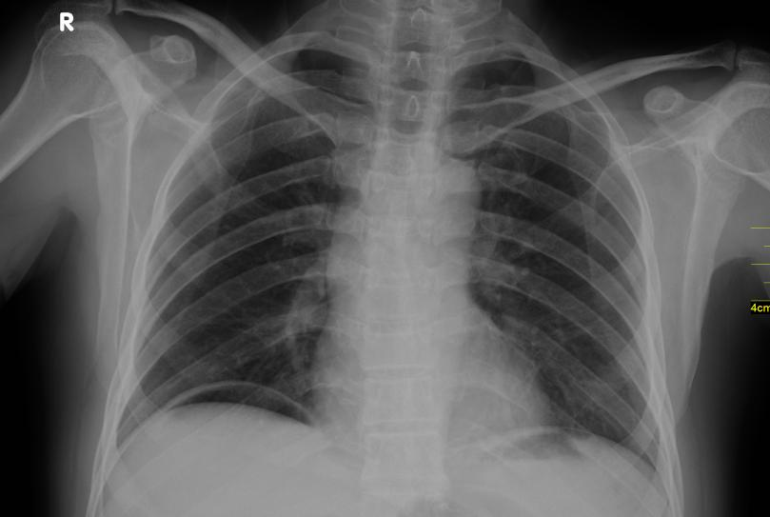
Now what?

- OR for ex lap. Your patient is hemodynamically normal through the case, you suction some free fluid, looks like bowel prep. How would you repair the perforation?
- Primary repair
- Vs resection with anastomosis +/- diversion

(Resident must be able to realize ability to offer primary anastomosis in hemodynamically stable patient , resident can divert their anastomosis / preferable over Hartman’s )

What if the site of the polypectomy/biopsy was highly suspicious for colon cancer and now presents with peritonitis, fever, and tachycardia?

- OR
  - Ex lap
  - Oncologic resection and anastomosis if able (high ligation of vessels). +/- diversion. (Depending on the location of the tumor, and the location of the perforation)

Scenario 2: Same patient presents 36 hours after hot snare polypectomy of 1cm lesion in the ascending colon with abdominal pain in the right hemiabdomen, focal guarding in the right mid abdomen, and mild leukocytosis of 13000. CT demonstrates thickening of small segment of ascending colon, no pneumoperitoneum or free fluid.
What is your Diagnosis ?
- Postpolypectomy syndrome.

How would you manage it?
  - NPO
  - IVF
  - IV antibiotics then PO abx.

Scenario 3: Same patient presenting 4 hours post colonoscopy after passing out at home while attempting to stand, and complaining of significant left sided abdominal pain that is now more diffuse.
He’s tachycardic to 115, BP 100/80, hemoglobin 9 from 14 pre-procedure. Exam reveals distention of the abdomen and diffuse guarding.
What is your differential diagnosis?
  - splenic laceration.
  - Hemorrhage from polypectomy site.

CT demonstrates splenic laceration with active extravasation and hemoperitoneum. How would you manage?

- IVF
- Type and cross
- Transfuse if becomes unstable.
- OR for ex lap, splenectomy vs. IR embolization.

Pitfalls:
- Not knowing the differential diagnosis.
- Not knowing post polypectomy syndrome and management.
- Should be able to consider anastomosis if hemodynamically stable.
- Not knowing risk of splenic laceration after colonoscopy.

Reference: https://www.asge.org/docs/default-source/education/practice_guidelines/doc-56321364-c4d8-4742-8158-55b6bef2a568.pdf

